Python Program

# ---------------------------------------------------------

# AI & ML LABORATORY PRACTICAL

# PR1: Intelligent Agents and PEAS Representation

# Title: Design and Implement a Simple Intelligent Agent

# Application: Smart Home Controller using PEAS

# ---------------------------------------------------------

# Create a class named SmartHomeAgent

class SmartHomeAgent:

# Constructor method

# It is automatically executed when the object is created

def __init__(self):

# Display the title of the practical

print("\n========== SMART HOME INTELLIGENT AGENT ==========\n")

# Display PEAS Representation

print("PEAS Representation")

print("------------------------------")

# Display Performance Measure

print("Performance Measure : Comfort, safety, energy saving and fast response.")

# Display Environment

print("Environment : Smart home including rooms and main door.")

# Display Actuators

print("Actuators : Light, Fan, AC and Door Lock.")

# Display Sensors

print("Sensors : Temperature, Motion, Light and Door sensors.")

# Display separator

print("------------------------------\n")

# Function to process sensor values and generate actions

def respond(self, temperature, motion, light, door):

# Display that the agent is processing the sensor data

print("\nProcessing sensor information...")

# ---------------- LIGHT DECISION ----------------

# Check whether motion is detected and room is dark

if motion == "yes" and light == "dark":

# Turn ON the light

light_action = "Light: ON"

else:

# Turn OFF the light

light_action = "Light: OFF"

# ---------------- FAN DECISION ----------------

# Check whether temperature is 25 degree Celsius or more

if temperature >= 25:

# Turn ON the fan

fan_action = "Fan: ON"

else:

# Turn OFF the fan

fan_action = "Fan: OFF"

# ---------------- AC DECISION ----------------

# Check whether temperature is 30 degree Celsius or more

if temperature >= 30:

# Turn ON the AC

ac_action = "AC: ON"

else:

# Turn OFF the AC

ac_action = "AC: OFF"

# ---------------- DOOR DECISION ----------------

# Check whether the main door is closed

if door == "closed":

# Lock the door

door_action = "Door Lock: LOCKED"

else:

# Keep the door unlocked

door_action = "Door Lock: UNLOCKED"

# Return all actions performed by the agent

return light_action, fan_action, ac_action, door_action

# ---------------------------------------------------------

# MAIN PROGRAM STARTS HERE

# ---------------------------------------------------------

# Create an object of SmartHomeAgent class

agent = SmartHomeAgent()

# Display the working steps of the intelligent agent

print("Agent Behaviour")

print("------------------------------")

print("1. Sense -> Read sensor information")

print("2. Think -> Process sensor values")

print("3. Act -> Control home appliances")

print("4. Repeat -> Continue monitoring")

print("------------------------------")

# Start an infinite loop

while True:

# ---------------- SENSOR ----------------

# Read temperature from the user

temperature = float(input("\nEnter room temperature (°C): "))

# Read motion sensor information

motion = input("Is motion detected? (yes/no): ").lower()

# Read light sensor information

light = input("Is the room light condition bright/dark? ").lower()

# Read door sensor information

door = input("Is the main door open/closed? ").lower()

# ---------------- THINK ----------------

# Pass sensor values to the intelligent agent

actions = agent.respond(

temperature,

motion,

light,

door

)

# ---------------- ACTUATOR ----------------

# Display the decisions taken by the agent

print("\n========== AGENT ACTIONS ==========")

# Display light status

print(actions[0])

# Display fan status

print(actions[1])

# Display AC status

print(actions[2])

# Display door lock status

print(actions[3])

# Display separator

print("===================================")

# Ask user whether they want to continue

choice = input(

"\nDo you want to continue monitoring? (yes/no): "

).lower()

# Check whether user wants to stop

if choice == "no":

# Display successful completion message

print("\nSmart Home Agent executed successfully!")

# Display thank-you message

print("Thank you!")

# Exit the loop
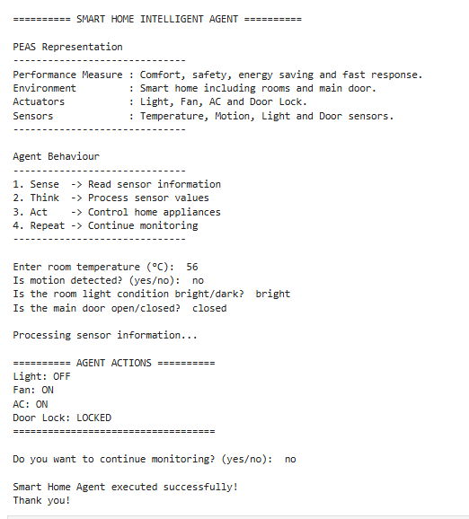
break
Output

